Bobcat Claws - Checkout

Group Members: Zimzy B, JD E, Yasbeth P

Project Outline: Bobcat Claws is a Texas State University local store price comparer. We plan to expand on the existing website to allow users to compare products based on price (given price and full price+tax included) and other product details such as quantity, brand, price per ounce, availability, markup price, and store location.

Bobcat Claws should provide accurate, up-to-date information on products that users search for. No log-in should be required for app usage, but should be available to users for additional features. Additionally, Bobcat Claws should not accept sponsors or advertisements.

Backend Overview:

ParseAPI will scrape product data from vendor sites. Scraped product data will be stored in a MySQL database and interact with a Node.js server to display information dynamically to the user.

Because this is a legacy system to be expanded on, the foundations for how the system interacts with the database are already laid. Here’s a simple diagram of how the frontend and backend will communicate with each other (sourced from the previous team’s documentation):

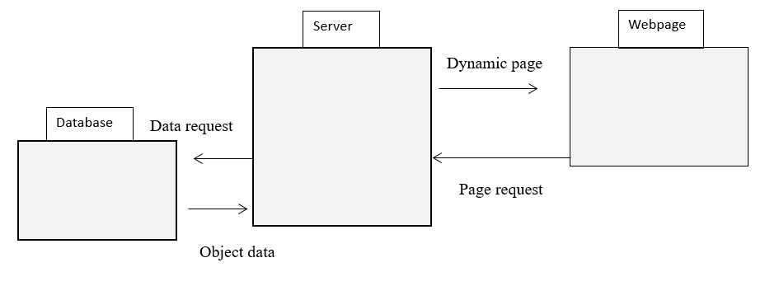
Sequence Diagram:
